CLIENT

Send Submissions to Email

This request can only be done by a System Administrator

Log a Service Desk request

Required information:
Provide Form URL or Asset No:
URL/Asset No:
Task Name:
(this becomes part of the log filename: submissions_log_”JOB NAME”(“DATE RANGE of LOG”)

Details:
- When --- The Start date is when the trigger is set to start
Options: (date & time or in [minutes/hours/days/weeks/months/years])
- Repeat process every --- Options: (minutes/hours/days)
Example: Trigger is set up with
Start on 19th July 2013 at 9:15pm and will repeat the run every 7 days.

Submission Log
Two options:
- The last run
- The given “Start” date (fixed date and time/period relative to current date and time)

Email:
Email address for the Submission logs to be sent
Email Subject line
Message text (OPTIONAL)

SD-WEB/TI-WEB

Send Submission to Email Setup

Setup can only be done by a System Administrator
Right click on your form and choose “Submission Logs”
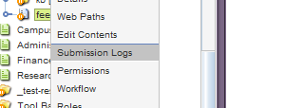
Acquire Locks
“Send Submissions To Email”
- “Add new job” type in a name eg: JOB NAME
(this becomes part of the log filename: submissions_log_”JOB NAME”(“DATE RANGE of LOG”)
- Choose a [date and time] and a repeat time
Both options are required otherwise you will get an error and job won’t save)
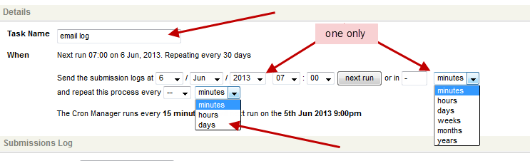
Click SAVE

Scheduled Job
You will need to configure this “Scheduled Job” more precisely,– Click the [Edit]
NOTE: Every change in this mode requires the “REPEAT this process” within the Details area to configured
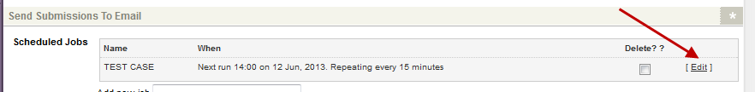

Details
Ensure you have the correct configurations within the Details

Submission Log
Choose your “Submission Logs” settings:
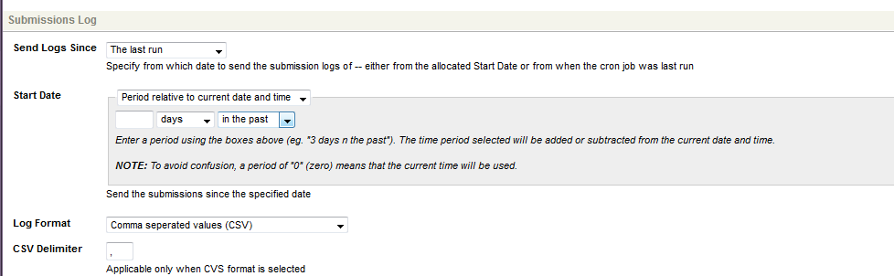

Email Format
Configure the email with:
- Email address for the Submission logs to be sent
- Email Subject line
- Message text (OPTIONAL)
SAMPLE:
This is an automated response, you will receive this report every 7 days.
Please log a service desk request if this email submission needs to be change/updated.

Started 21st Oct 2013
From: http://student.csu.edu.au/campus/residences/requests-forms/event
ID: #%asset_assetid%

Outlook Email
To open the attached log file; user’s will need to save the attached file with the “.csv” extension
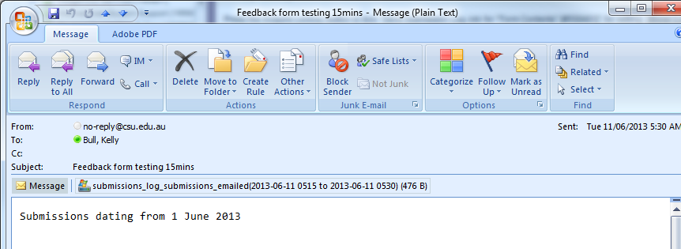

CSV/EXCEL file:
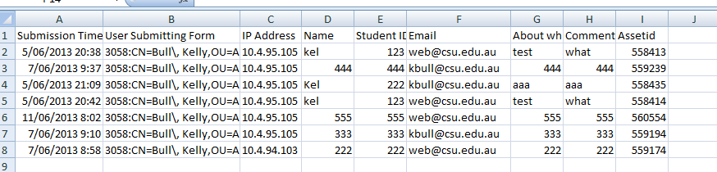

Existing Forms
https://student.csu.edu.au/administration/graduations/hong-kong-graduation/application-to-graduate [295896]
https://student.csu.edu.au/campus/residences/requests-forms/event [207313]

